**BANK LOAN REPORT QUERIES**

1. **BANK LOAN REPORT | SUMMARY**

**KPI’s:**

**Total Loan Applications:**

SELECT

COUNT(id) AS Total_Applications

FROM

financial_loan

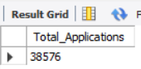

**MTD Loan Applications**

SELECT

COUNT(id) AS Total_Applications

FROM

financial_loan

WHERE

MONTH(STR_TO_DATE(issue_date, '%d-%m-%Y')) = 12;

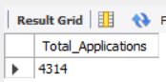

**PMTD Loan Applications**  
SELECT

COUNT(id) AS Total_Applications

FROM

financial_loan

WHERE

MONTH(STR_TO_DATE(issue_date, '%d-%m-%Y')) = 11;

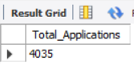

**Total Funded Amount**

SELECT

SUM(loan_amount) AS Total_Funded_Amount

FROM

financial_loan

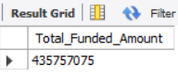

**MTD Total Funded Amount**

SELECT

SUM(loan_amount) AS Total_Funded_Amount

FROM

financial_loan

WHERE

MONTH(STR_TO_DATE(issue_date, '%d-%m-%Y')) = 12;

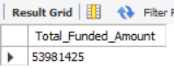

**PMTD Total Funded Amount**

SELECT

SUM(loan_amount) AS Total_Funded_Amount

FROM

financial_loan

WHERE

MONTH(STR_TO_DATE(issue_date, '%d-%m-%Y')) = 11;

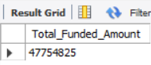

**Total Amount Received**

SELECT

SUM(total_payment) AS Total_Amount_Collected

FROM

financial_loan

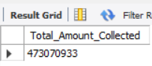

**MTD Total Amount Received**

SELECT

SUM(total_payment) AS Total_Amount_Collected

FROM

financial_loan

WHERE

MONTH(STR_TO_DATE(issue_date, '%d-%m-%Y')) = 12;

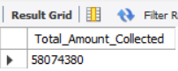

**PMTD Total Amount Received**

SELECT

SUM(total_payment) AS Total_Amount_Collected

FROM

financial_loan

WHERE

MONTH(STR_TO_DATE(issue_date, '%d-%m-%Y')) = 11;

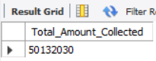

**Average Interest Rate**

SELECT

ROUND(AVG(int_rate) * 100, 2) AS Avg_Int_Rate

FROM

financial_loan;

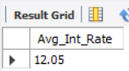

**MTD Average Interest**

SELECT

ROUND(AVG(int_rate) * 100, 2) AS MTD_Avg_Int_Rate

FROM

financial_loan

WHERE

MONTH(STR_TO_DATE(issue_date, '%d-%m-%Y')) = 12;

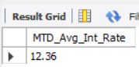

**PMTD Average Interest**

SELECT

ROUND(AVG(int_rate) * 100, 2) AS MTD_Avg_Int_Rate

FROM

financial_loan

WHERE

MONTH(STR_TO_DATE(issue_date, '%d-%m-%Y')) = 11;

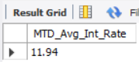

**Avg DTI**

SELECT

ROUND(AVG(dti) * 100, 2) AS Avg_DTI

FROM

financial_loan

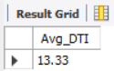

**MTD Avg DTI**

SELECT

ROUND(AVG(dti) * 100, 2) AS MTD_Avg_DTI

FROM

financial_loan

WHERE

MONTH(STR_TO_DATE(issue_date, '%d-%m-%Y')) = 12;

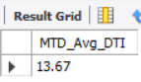

**PMTD Avg DTI**

SELECT

ROUND(AVG(dti) * 100, 2) AS MTD_Avg_DTI

FROM

financial_loan

WHERE

MONTH(STR_TO_DATE(issue_date, '%d-%m-%Y')) = 12;

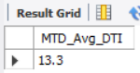

**GOOD LOAN ISSUED**

**Good Loan Percentage**

SELECT

ROUND((COUNT(CASE

WHEN

loan_status = 'Fully Paid'

OR loan_status = 'Current'

THEN

id

END) * 100.0) / COUNT(id),

2) AS Good_Loan_Percentage

FROM

financial_loan

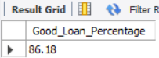

**Good Loan Applications**

SELECT

COUNT(id) AS Good_Loan_Applications

FROM

financial_loan

WHERE

loan_status = 'Fully Paid'

OR loan_status = 'Current'

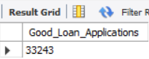

**Good Loan Funded Amount**

SELECT

SUM(loan_amount) AS Good_Loan_Funded_amount

FROM

financial_loan

WHERE

loan_status = 'Fully Paid'

OR loan_status = 'Current'

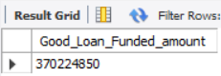

**Good Loan Amount Received**

SELECT

SUM(total_payment) AS Good_Loan_amount_received

FROM

financial_loan

WHERE

loan_status = 'Fully Paid'

OR loan_status = 'Current'

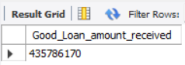

**BAD LOAN ISSUED**

**Bad Loan Percentage**

SELECT

ROUND((COUNT(CASE WHEN loan_status = 'Charged Off' THEN id END) * 100.0) /

COUNT(id), 2) AS Bad_Loan_Percentage

FROM financial_loan

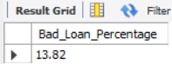

**Bad Loan Applications**

SELECT

COUNT(id) AS Bad_Loan_Applications

FROM

financial_loan

WHERE

loan_status = 'Charged Off'

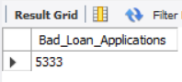

**Bad Loan Funded Amount**

SELECT

SUM(loan_amount) AS Bad_Loan_Funded_amount

FROM

financial_loan

WHERE

loan_status = 'Charged Off'

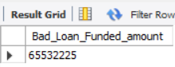

**Bad Loan Amount Received**

SELECT

SUM(total_payment) AS Bad_Loan_amount_received

FROM

financial_loan

WHERE

loan_status = 'Charged Off'

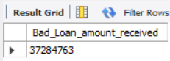

**LOAN STATUS**

SELECT

loan_status,

COUNT(id) AS LoanCount,

SUM(total_payment) AS Total_Amount_Received,

SUM(loan_amount) AS Total_Funded_Amount,

ROUND(AVG(int_rate * 100), 2) AS Interest_Rate,

ROUND(AVG(dti * 100), 2) AS DTI

FROM

financial_loan

GROUP BY

loan_status

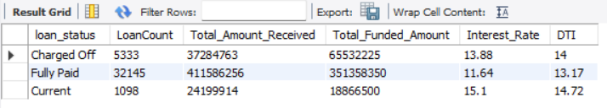

SELECT

loan_status,

SUM(total_payment) AS MTD_Total_Amount_Received,

SUM(loan_amount) AS MTD_Total_Funded_Amount

FROM financial_loan

WHERE

MONTH(STR_TO_DATE(issue_date, '%d-%m-%Y')) = 12

GROUP BY loan_status;

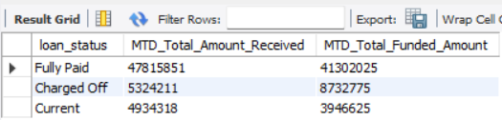

1. **BANK LOAN REPORT | OVERVIEW**

**MONTH**

SELECT

MONTH(STR_TO_DATE(issue_date, '%d-%m-%Y')) AS Month_Number,

MONTHNAME(STR_TO_DATE(issue_date, '%d-%m-%Y')) AS Month_Name,

COUNT(id) AS Total_Loan_Applications,

SUM(loan_amount) AS Total_Funded_Amount,

SUM(total_payment) AS Total_Amount_Received

FROM financial_loan

GROUP BY

MONTH(STR_TO_DATE(issue_date, '%d-%m-%Y')),

MONTHNAME(STR_TO_DATE(issue_date, '%d-%m-%Y'))

ORDER BY

MONTH(STR_TO_DATE(issue_date, '%d-%m-%Y'));

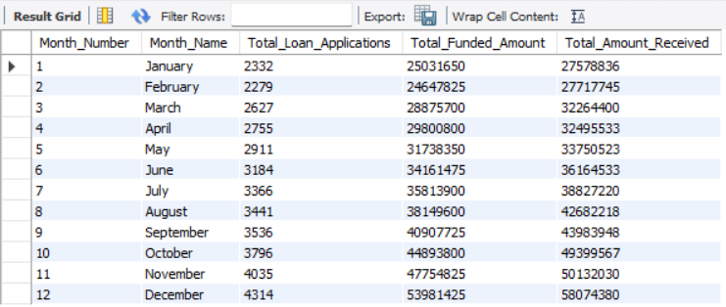

**STATE**

SELECT

address_state AS State,

COUNT(id) AS Total_Loan_Applications,

SUM(loan_amount) AS Total_Funded_Amount,

SUM(total_payment) AS Total_Amount_Received

FROM financial_loan

GROUP BY address_state

ORDER BY address_state

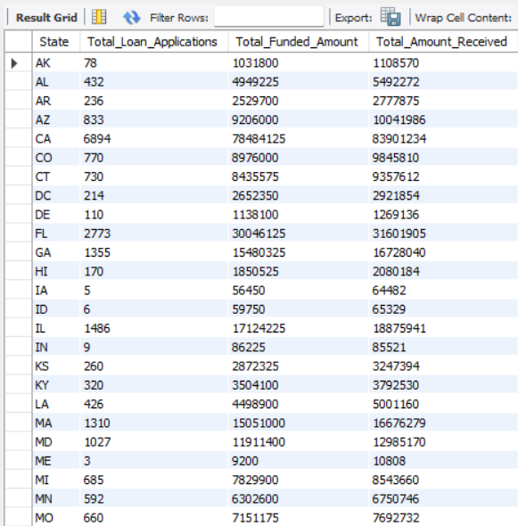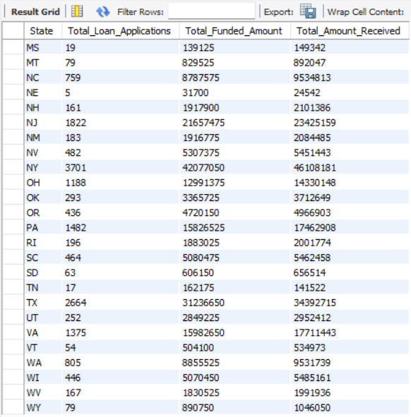

**TERM**

SELECT

term AS Term,

COUNT(id) AS Total_Loan_Applications,

SUM(loan_amount) AS Total_Funded_Amount,

SUM(total_payment) AS Total_Amount_Received

FROM

financial_loan

GROUP BY term

ORDER BY term

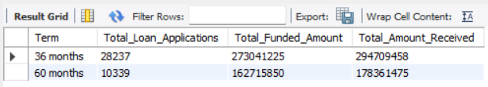

**EMPLOYEE LENGTH**

SELECT

emp_length AS Employee_Length,

COUNT(id) AS Total_Loan_Applications,

SUM(loan_amount) AS Total_Funded_Amount,

SUM(total_payment) AS Total_Amount_Received

FROM

financial_loan

GROUP BY emp_length

ORDER BY emp_length

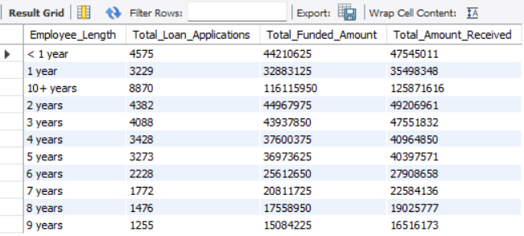

**PURPOSE**

SELECT

purpose AS PURPOSE,

COUNT(id) AS Total_Loan_Applications,

SUM(loan_amount) AS Total_Funded_Amount,

SUM(total_payment) AS Total_Amount_Received

FROM

financial_loan

GROUP BY purpose

ORDER BY purpose

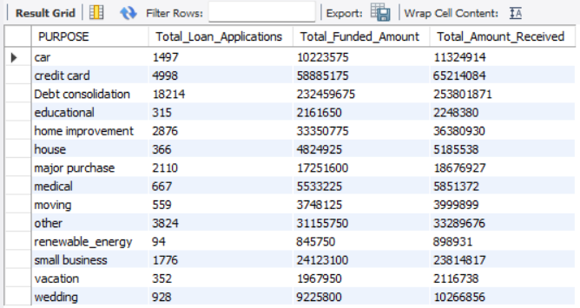

**HOME OWNERSHIP**

SELECT

home_ownership AS Home_Ownership,

COUNT(id) AS Total_Loan_Applications,

SUM(loan_amount) AS Total_Funded_Amount,

SUM(total_payment) AS Total_Amount_Received

FROM

financial_loan

GROUP BY home_ownership

ORDER BY home_ownership

